|  |  |  |  |  |
| --- | --- | --- | --- | --- |
| **Cornell High Energy Synchrotron Source** | | | | |
| **Doc#:** | **Procedure:** MM-PAD Setup/Usage/Shutdown | | | **Prepared by:** |
| **Rev.:** 1 | **Date Revised:** 7/20/2021 | **Date Effective:**  xx/xx/xxxx | **Date Expires:**  xx/xx/xxxx | **Approved by:** |

**Purpose**

To set up and control the MM-PAD for high-speed imaging

**Materials and Equipment Needed**

1. PILATUS Pixel Array Detector
2. PILATUS Power Supply (+12V DC, 60W)
3. PILATUS Nitrogen Adaptor
4. Nitrogen Supply and Hose
5. Rack-mount Control and Analysis PC
6. Station Computer
7. 2.5mm Allen Wrench
8. Flathead screwdriver
9. Cables
   1. Detector Power
   2. Data Transfer
   3. Computer power
   4. CHESS DAQ Cable

**Safety**

1. Minor Electrical Hazards – make sure all cables are properly connected and shielding is intact.
2. Safety Equipment Required: none

**Procedure**

**NOTE: Ensure detector window is covered with the protective plate when not in use to prevent damage from exposure.**

**A. Detector Setup**

1. Plug in AC power cables for rack and each component on the rack.
2. Connect vacuum to detector head and begin pumping. Detector head should be shipped/stored under vacuum with the valve closed (3/8” hex key via side access into detector head). Open valve (multiple turns CCW) when hose begins to rough down.
3. Connect water hoses to water chiller. Set to 22 C. Use deionized water.
4. Connect cables between head and rack.
   1. To PC - Ethernet cable to Detector ETH port and Camerlink cables (base/o and full/1)
   2. To Detector power box – Detector power cable, TC gauge, Thermal switch
   3. To TE controller – TE Power and RTD sensor
   4. To Keithley 2410 – Sensor Bias SHV cable (rear connection)
5. Turn on left-most power switch on detector power box. This powers the box and the detector FPGA.
6. When detector head vacuum is below 25 mTorr, interlocks can be reset. Press reset button at this point, energizing TE controller. Set the TE to 0 C (normal operating point) (Note, a second interlock is an 85F thermal switch on the detector housing. (If the water was not turned on, the TE will cause this interlock to trip – one might have to bring the water temp to 15 C to get this switch to reset. Bring the temperature back to 22 C after reset).
7. Turn on “detector power” switch next to reset button. This sends power to the detector head and energizes the Keithley 2410. Use bottom right pad on Keithley to select rear output. Set Keithly source range by pressing “up” key under “SOURCE”, which should cause a digit in Vsrc to blink. Press the up triangle on range to get to the kV range for the meter. Use software to set thebias via RS232 interface. NEVER go below -2V or above +400V. Software limits are in place for the voltage – hence use the software to set the voltage.

**B. Cart Setup (Control Computer)**

1. Turn on the control PC.
2. Open terminal and go to /home/padme/tvx_64/tvx/camera/camserver
   1. Alternatively, ssh
3. Start camserver with ./camserver
4. Mount the CHESS DAQ file system on the detector computer at /home/padme/currentdaq, if it isn’t already:
   1. Open terminal window on control PC.
   2. Type cd /home/padme/data
   3. Type ./daqmount
      1. Password: amidala
5. Single-click the **“Start Pilatus”** icon to start *camserver*, *areaDetector* IOC and *areaDetector medm GUI*.
   1. When prompted, enter the name of the beamline. **Note that this needs to be entered in uppercase (A1, G3, etc.)**
6. Verify that there are no communications errors in *camserver* or EPICS console windows.

**C. Station Computer Setup (all lines except G line)**

1. Start new terminal window on station computer. **If at G line, please go to Section D.**
2. Type pilatusview n where n is the Pilatus number to launch the *medm* GUI on the Station Computer. (**Fig. 4**)
3. Start desired version of *SPEC*.
4. Type ad_setup in *SPEC* command line to define operational parameters
   1. Mnemonic: PILN (where N is detector number)
   2. Remote Directory: /mnt/currentdaq/name-BTRID-cycle
      1. NOTE: Typically, USER is the PI surname, BTRID is the beamtime request number, cycle is the File ID found on the schedule in *userdb*.
      2. Use lineup for USER and MM-DD (month/day) for BTRID.
5. Type newfile to define a file name for *camserver* images and *SPEC* data files.
6. Type ad_on to enable detector communications.
   1. **NOTE: ad_on must be entered after changing Remote directory via ad_setup or changing file name via newfile command.**
7. Type ct 3 in *SPEC* command line to begin a 3 second exposure.
8. Verify the image in *ImageJ*:
   1. Open terminal window on Station Computer.
   2. Type ImageJ to start *ImageJ*.
   3. Images are located on the CHESS DAQ network file system, accessed through the mounted drive: /mnt/currentdaq/..

Shutdown

1. Type ad_off (or ad1_off and/or ad2_off if at G Line) in *SPEC* command line to disable EPICS communication.
2. Type ad_unsetup in *SPEC* command line to remove all *SPEC* areaDetector hooks. **If at G line, this command is unnecessary and will not work. Go to step 35.**
3. Close any open *medm* windows on station computer.
4. Double-click *Stop Pilatus* icon on detector control computer desktop to shut down *medm* GUI, *areaDetector* IOC, and *camserver*.
5. Shut down the control computer.
6. Disconnect CHESS Public Network cable from rear of control computer. (**Fig. 2**)
7. Replace protective window on front of detector.
8. Press power switch on rear of detector to power the unit off.
9. Disconnect N2 line from quick-connect N2 adapter. (**Fig. 1**)
10. Disconnect Detector Power cable from rear of detector. (**Fig. 1**)
    1. Place power adapter in Detector Cart.
11. Loosen the Detector Data cable with the 2.5 mm Allen Wrench and remove cable. (**Fig. 1**)
    1. Cable should not be disconnected from rear of detector computer.
    2. Place cable in Detector Cart.
12. Replace rear cover plate on detector.
13. Place detector in Dry Storage container and place the container in the detector cart.
14. Unplug power from detector cart.
15. Notify CHESS Detector group that the unit has been disconnected.

**Figures**

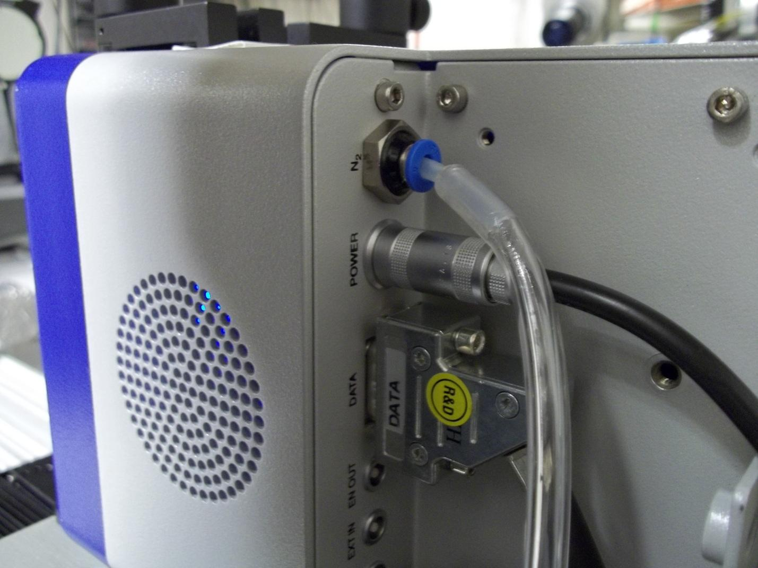

Detector Power

N2 Adapter

Detector Data

**Figure 1: Detector Nitrogen port, Power plug, Data plug**

**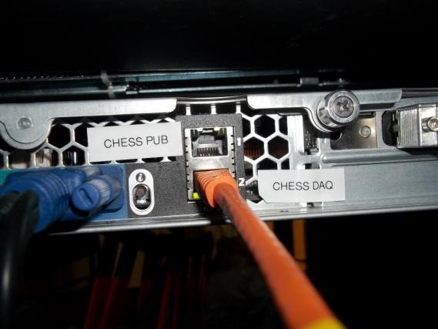 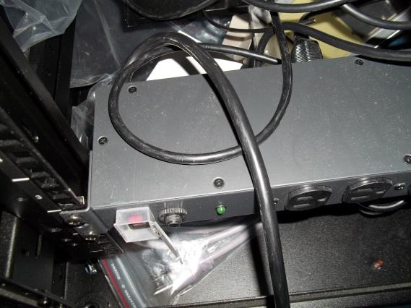****Figure 2: Port for CHESS DAQ network cable Figure 3: Power strip cable**

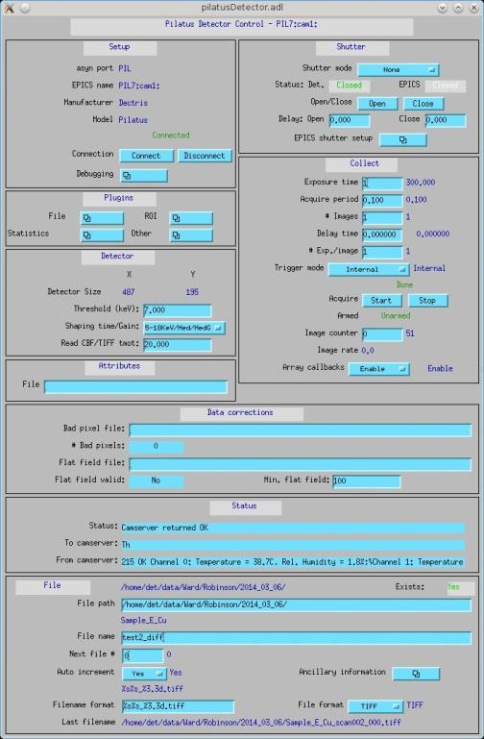

Energy Threshold Settings

**Figure 4: Pilatus *medm* GUI**

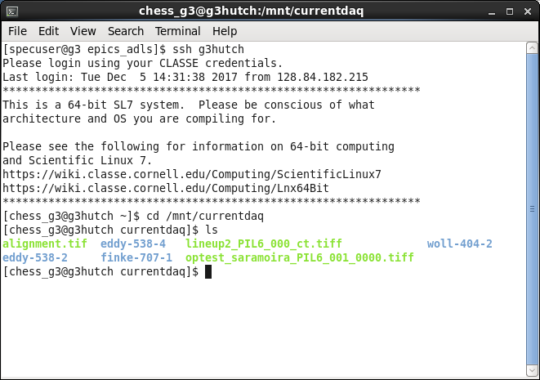

**Figure 5: Checking that files are written to the hutch computer (G line instructions)**

**SPEC commands for MM-PAD**

|  |  |
| --- | --- |
| **mmpad_cdte_Jun2021v1.mac** | |
| mmpad_set_path [PATH] | * Allows user to set the path MM-PAD saves images at * Optional path argument |
| mmpad_detector_setup | * Turns on the MM-PAD detector board and Keithley HV power supply |
| mmpad_server_setup [IP:PORT] | * Establishes connection to the camserver instance * Optional argument for the IP and port of camserver instance |
| mmpad_set_trigger [software|hardware] | * Allows user to set the trigger mode for the MM-PAD * Optional arguments of software or hardware |
| mmpad_on_new [auto] | * Holistic macro that gets the MM-PAD into image-ready state with user input * Optional “auto” argument that arms the MM-PAD without user input |
| mmpad_status | * Prints all values from global associative array MMPAD[] to terminal |
|  |  |
|  |  |
|  |  |
|  |  |
|  |  |
|  |  |

|  |  |
| --- | --- |
| **sync_daq.mac** | |
|  |  |
|  |  |
|  |  |

**Troubleshooting**

|  |  |
| --- | --- |
| **Communications Error in camserver** | |
| Control PC does not have network address. | 1. Verify network connection 2. Restart control PC |
| Detector not on | 1. Single-click **“Stop Pilatus”** icon on desktop of control PC to stop software. 2. Verify data transfer cable connections. 3. Verify Power status of detector |

|  |  |
| --- | --- |
| **Communications error in EPICS** | |
| Camserver Error | 1. Verify *camserver* status 2. If in error state, see Communcations Error in camserver section. |
| “PV on Multiple Servers” | 1. Single-click **“Stop Pilatus”** icon on desktop of control PC to stop software. 2. Open a new terminal window. 3. Type ps -a to verify if any related processes are still running. 4. Type killall camserver to stop remaining camserver process. 5. Type killall pilatusDetector to stop remaining EPICS IOC. 6. Single-click **“Start Pilatus”** icon on desktop of control PC to restart software. |

|  |  |
| --- | --- |
| **Communications error in *SPEC*** | |
| “Not a command or macro” | 1. Type udo area_detector.mac in *SPEC* command line to load macro file for detector. |
| “Error on epics_get” | 1. Press <Ctrl + C> to stop the macro. 2. Verify network connection to control computer. 3. Single-click **“Stop Pilatus”** icon on desktop of control PC to stop software. 4. Single-click “**Start Pilatus**” icon on desktop of control PC to restart software. |
| ct command freezes *SPEC* | 1. Type ad_on to enable detector communications. |

|  |  |
| --- | --- |
| **Black Image** | |
| Cover plate in place | 1. Remove protective plate from detector. |
| Energy Threshold too high | 1. Enter desired Energy Threshold value in *areaDetector* GUI. (**Fig. 4**)    1. If threshold setting is correct, value may still need to be entered manually to ensure that input and readback are in sync. 2. Adjust as necessary for incident energy used. |
| Brightness/Contrast levels | 1. Click “Auto” in ImageJ Adjust window to scale levels for the image. |

**References**

* *DECTRIS PILATUS Manual*, “Getting Started”: Section 2, pgs 20-21.

**Revision History**

Rev. 1 - Initial document (07/20/2021)